**Advance Deep Learning based Chatbot built using Natural Language Processing and Keras Neural Networking**

**Aravinth S**

Department of Computer Science and Business Systems

Sethu Institute of Technology, Pulloor, Kariapatti. 626 115, India

[aravinths741@gmail.com](mailto:aravinths741@gmail.com)

***Abstract –* In our modern lifestyle technologies such as smartphone, online shopping, home automation makes our life more convenient, allowing us to save time and energy. The internet has made information easily accessible, providing access to knowledge and resource that would have been difficult to obtain in past. Technology has made things easier, so that people can work remotely to collaborate on projects, and automate tedious tasks, resulting in increased productivity and efficiency. Due to this people are expecting their lifestyle to me more and more easy, to solve this a chatbot is introduced for making lifestyle more efficient and enjoyable. This chatbot will be a greater good for both the user and the handler because it allows them both to control the entire operation according to their need. This chatbot is built upon artificial intelligence, machine learning, and deep learning which allows the application to improve its efficiency and think more. This chatbot is now being tuned for Tamil Nadu government websites to make the process of navigation much faster and safer. This chatbot can assists the users to navigate through the website or the service they seek. It helps them to pay their bill and taxes. This chatbot can download your identification proofs, documents you need. Also, it can give you the locations of the buildings, officers details, timings, toll-free numbers and so on. This chat is a web-based application so it can be used in any devices on any operating system. Deployment of this chatbot can change the pace of all the government websites and services. Further details of this chatbot are discussed below in detail.**

***Keywords – Chatbot, Artificial intelligence, Machine learning, Natural language processing, Artificial neural network.***

1. Introduction

In the 21st century, Development in technology is one of the best foremost things happened to us. Improvement of technology is both boon and bane, People are now addicted to the technology that their entire life is totally depended upon the machines. Even though we know that technology is slowly consuming us, we are still in the situation where we cannot live without it. There are around 1.13 billion websites in the world and a new website is being built for ever there three seconds. On average one person in United States uses around 130 websites per day [1] and managing these websites may be a difficult task. Around seventy-one percentage of the business now own a website, in which twenty-eight percent of the business is entirely done in online mode [1]. According to the survey taken by Forbes advisor survey held on February 14-2023, the maximum waiting time of the user while using a website is 54 seconds. Due to the delay and difficulties in navigation of the particular webpage 88% of the users does not return to the website [1]. To solve this problem an artificial intelligence based chatbot that adapts to the nature of the website is deployed along with the website. This chatbot can improve the efficiency of the websites drastically.

A chatbot is a computerized program that acts as a conversational median between the human and the bot, it is a virtual assistance that has become exceptionally popular [2]. These chatbot communicate with the human users and collect the data with interactive queries and process it with machine learning to make it far more advance than the previous version. Theses conversational application have become more responsive and the art of the conversation between the humans and machines over the past few years have improved drastically.

1. Background

Even this chatbot can be classified into several types according to the character and behaviour of the question handled by the bot. Chatbot are classified based on the case of algorithms, user-interface and underlying technologies used in it. According to the characteristics chatbots can be mainly classified into three major types.

**Menu/Button – Based chatbots**

The simplest and the most commonly used chatbot is menu (or) button based chatbot. In this chatbot there are only limited number of pre-defined answers will be available in the form of buttons. This chatbot follows the principle of decision tree, were your question leads to only the same answer every time it is raised.

**Keyword Recognition – Based chatbots**

In this chatbot, the algorithm searches for a specific keyword in order to produce the required result. The entire input will not process in this algorithm. Only the particular keyword will be processed. There is high chance of failure of this chatbot when it comes across the same keyword redundancies between different queries.

**Contextual chatbots**

The most advanced and intelligent chatbot available at present is the contextual chatbot. This chatbot uses machine language, artificial intelligence technology and advanced algorithms such as speech recognition, speech-to-text conversion algorithms. This chatbot learns and grows overtime by requiring intellectual queries from the users and improve its efficiency.

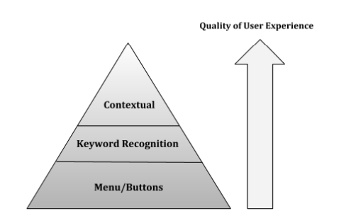

Fig. 1. Preference of chatbot

In figure 1, the usage and the preference of the chatbot are classified according to the efficiency of the algorithm and the under lying technology that the chatbot is built on. The usage of the chatbot depends upon how the developer wants to process the input to give a desired output.

1. Related Work
   1. *A.L.I.C.E. Chatbot system*

A.L.I.C.E. (or) Artificial Linguistic Internet Computer Entity was first implement by Wallace in 1995. Alice’s knowledge about English Conversational patterns is stored in AIML files. AIML also known as Artificial Intelligence Mark-up Language is derived from Extensible Mark-up Language (XML). It was developed by Wallace and the Alicebot free software community from 1995 onwards to input dialogue pattern knowledge into chatbot based on the A.L.I.C.E. open-source technology.

AIML consists of data objects called AIML objects. This AIML objects are made up of units called categories and topics. The topic is an optional top-level element which has a name attribute and a set of categories related to the topic. Categories are the basic knowledge unit in AIML. Each and every category is a rule of matching an input and converting it to an output. This category consists of pattern, which matches with the user input and a pre-defined template which is used in generating Alicebot answers [4]. The format of AIML Language is given in the figure 2:

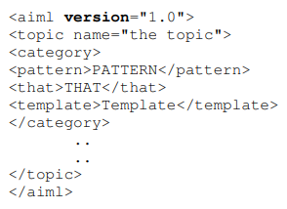

Fig. 2. Format of AIML Language

The AIML pattern is so simple, easy, consisting only spaces, words, and the wildcard symbols _ and *. The words may consist of letters and numerical, but no other special characters. Words are separated by single space, and the wildcard symbols functions like words. The pattern language is case invariant. The idea of finding the matching technique is based on the finding the best, longest, pattern match.

* 1. *Dedicated chatbot for websites*

Communicating with the customers through live chat interface has become an increasingly popular means to provide real-time customer service. Websites that are currently managing businesses requires 24/7 customer service. So that, the websites are forced to have a chatbot service which is built dedicatedly for only particular website. For example, a website that sells cloths requires a chatbot related to it. Whereas, for another website a chatbot had to build from scratch.

Dedicated chatbots are the chatbots that are solely built for only one website. The purpose and the pattern of this chatbot cannot be altered if wanted to. The developer is the only person capable of building this chatbot along with website, because he/she is the only one who understands how the website works.

These dedicated chatbots uses different technologies according to the developer. Any change in the chatbot will result in entire replacement of the technology that the chatbot is built on. One of the key advantages of dedicated chatbot on a website is that it provides round-the-clock support to the visitors. Visitors can interact with the chatbot anytime, even outside the business hours. This means that the visitors can get the information they need or resolve their queries quickly without having to wait for a human support agent.

*C. Advance AI-Based Chatbot*

An AI-based chatbot is a computer program that uses artificial intelligence (AI) techniques such as machine learning and natural language processing (NLP) to communicate with the uses through text or voice-based conversations. Chatbots can be integrated into websites, mobile applications, messaging platforms, and other digital channels to provided automated customer service, sales, and support.

AI-based chatbots can analyse users input and provide relevant responses based on pre-defined rules, historical data, and machine learning algorithms. They can also learn from user interaction to improve their accuracy and effectiveness over time. This ability to leant from user data and adapt to changing circumstance makes chatbots a powerful tool for businesses to improve their customer experience and reduce costs associated with human support. AI-based chatbots are an evolving entity that adapts and works according to the environment. Most of the AI/ML based chatbots that are in use is far more advance than we expected. People across the world are aware that Artificial Intelligence based chatbots will rule over the internet.

Most of these AI-based chatbot are built on Chatterbot library. Chatterbot is an open-source python library for building chatbots. It provides a simple and flexible way to create conversational agents that can simulate human conversation. The package offers various functionalities such as training the chatbot, storing the conversation data, and processing natural language. Chatterbot uses machine learning algorithm to generate responses to user inputs. The packages come with several pre-trained models that can be used to generate responses to common questions. However, the library is highly customizable, and users can train their chatbot models with their own data.

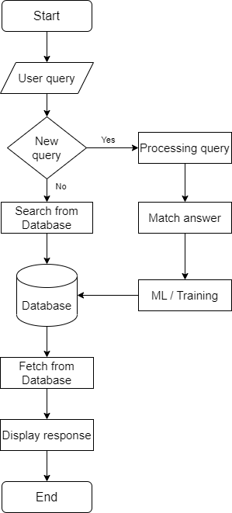

Fig. 3. Flowchart of Chatterbot

Some of the main components of the chatterbot packages are:

1. *Corpus:* The package contains a built-in corpus of conversational data that can be used to train the chatbot. The corpus includes a collection of dialogues that the bot can us to generate responses.
2. *Trainer:* Chatterbot provides several training classes that can be used to train the chatbot with custom data. These classes can be used to train the bot with text data or even with conversational from chat logs.
3. *Storage:* Chatterbot allows for the storage of conversational data in various format such as SQLite, JSON, and MongoDB. This enables the chatbot to store and retrieve conversation data, making it possible to create more personalized responses.
4. *Filters:* The package provides a way to filter out certain words or phrases that are not appropriate for the chatbot’s responses. This can be useful when building a bot for a specific purpose, such as customer support.
5. *Language processors:* Chatterbot includes several languages processors that can be used to process natural language inputs. Theses processors can help the chatbot understand the context of the conversation and generate more accurate responses.
6. Methods

Considering all these existing solutions, we developed a chatbot that is capable of outperforming the Chatterbot library with much more accurate and efficient response. This chatbot is totally an API (Application Programming Interface) based software application, where any one can access and modify it. This chatbot uses python-Flask server as an underlying technology, which is common for all users. The chatbot can be totally customizable according to the handler. They have access to modifying the user interface, search algorithms, and response attributes. Since this chatbot is a web-based application, it can be operated on any device without regarding the operating system. This chatbot can train both the questions and answers for fast and reliable response. This chatbot consists of multiple AI/ML technologies for processing the data, they are:

1. *NLTK:* NLTK (or) Natural Language Toolkit is a python library designed to enable natural language processing (NLP) tasks such as tokenizing, stemming, tagging, parsing, and semantic reasoning [6]. It provides an extensive collection if tools and resources for working with human language data, making it a popular choice among researchers, students, and developers who work with NLP [6].
2. *Pickle:* The ‘Pickle’ library in python is a way to [7] serialize and deserialize python objects, which means that it allows you to convert complex python objects into a stream of bytes that can be saved to file or transmitted over a network. Pickle can also convert the stream of bytes back into a python object when you need it again. The process of converting objects into a stream of bytes is called “Pickling”, while the reverse process of converting the stream of bytes back into a python object is called “Unpickling” [7].
3. *Keras:* Keras is a high-level open-source neural network library written in python. It is built on top of TensorFlow and allows user to quickly build and prototype deep learning models with a minimal amount of code [8]. Keras provides a user-friendly Application Programming Interface for building and to training deep learning models. It can support both recurrent and convolutional neural networks, as well as both. Keras also allows users to build models using multiple inputs and outputs, making it a powerful tool for complex machine learning problems [8]. Also, it is used for making a modular architecture.
4. *NumPy:* NumPy is a popular python library for scientific computing that provides support for numerical operations on large, multi-dimensional arrays and matrices. It stands for Numerical python and is a fundamental package for scientific computing with python.
5. *TensorFlow:* TensorFlow is a popular open-source library for building and training machine learning models. It was developed by Google and is widely used in various applications such as natural language processing, computer vision, speech recognition, and more. TensorFlow provides a comprehensive suite of tools and libraries for building and training neural networks. A neural network is a computational model that is designed to simulate the behaviour of the human brain. It is composed of layers of interconnected nodes, called neurons, that work together to solve a specific task. Each neuron takes input from other neurons or from an external source, performs some computation on this input, and then passes its output to other neurons.

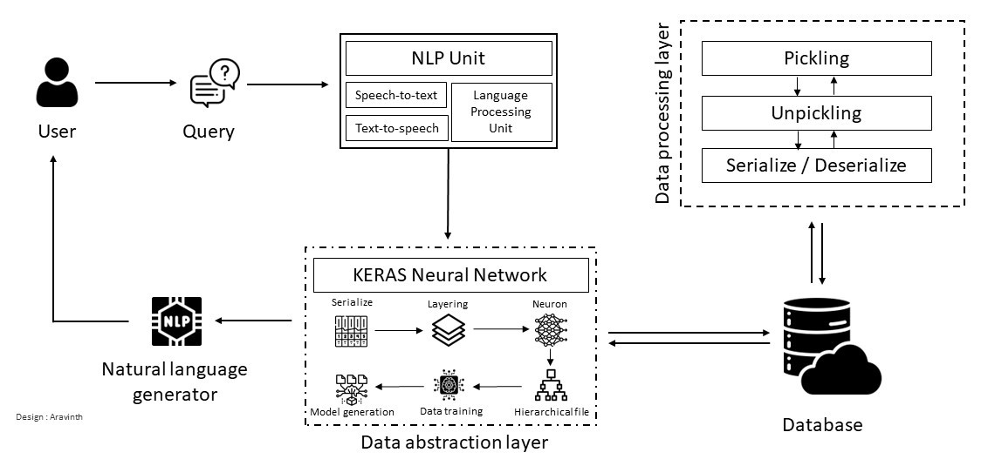

Fig. 4. Workflow of Keras based chatbot

1. Keras Neural Networking

Keras is a high-level neural network API that is written in python and runs on top of TensorFlow, Theano, or CNTK. It is designed to enable fast experimentation with deep neural networks and it provides a user-friendly API that makes building deep learning models easy [8-9].

In Keras, a neural network is built by creating a model object and adding layers to it. A layer is a fundamental building blocks of a neural network, and Keras provides a wide range of pre-built layers that can be easily added to the model. To build a neural network in Keras there are certain steps involved they are [8]:

1. *Define the model:* In Keras, you can define a model by creating a sequential model object and adding layers to it. In the multiple layers, the first layer has 64 units and uses ReLU activation function. The second layer of the Keras structure has 10 units and uses the SoftMax activation function to process it.
2. *Compile the model:* Once the model is defined, you need to compile it using Keras compile method. This method takes three arguments: the optimizer, the loss function, and the evaluation metric.
3. *Train the model:* Once the model is compiled, you can train it on your data using Layer method. This method takes the input data, the target data, and the number of epochs to train for as arguments. [8] The model is trained for 10 epochs with a batch size of 32 and 64 respectively.
4. *Evaluate the model:* Once the model is trained, you can evaluate its performance on new data using evaluate function. This method takes the input data and the target data as arguments.
5. *Make predictions:* Once the model is trained, you can use it to make prediction on new data using the Keras prediction method.

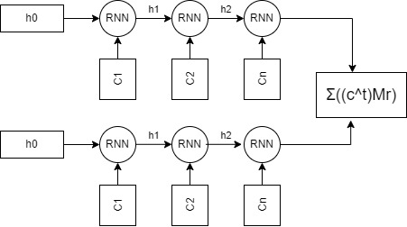

Fig. 5. Retrieval based Keras model

1. Application Development
   1. *User interface*

User interface of this web-application is simple and user-friendly. The bubble of the chatbot is placed in far down-right corner for easier attraction. The user interface displays the basic information such as user’s personal details like name, unique ID, and mail address along with the current date and time. Users will be given a popup warning of privacy policy before the usage of the chatbot, as the chatbot collects data from the interaction between the user and chatbot.

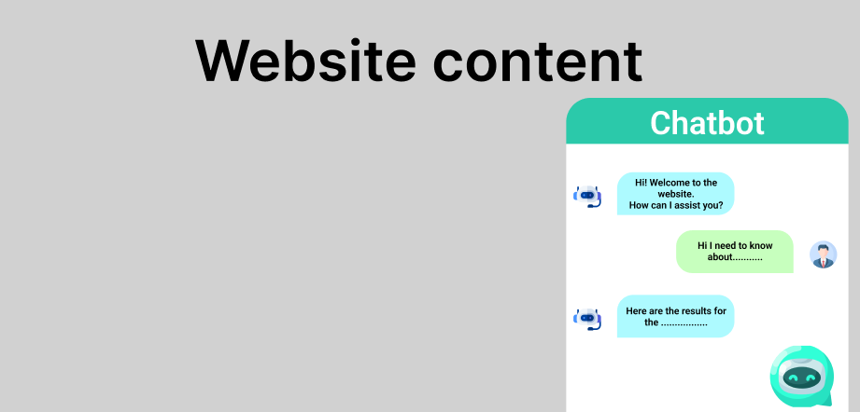

Fig. 6. User interface for desktop version

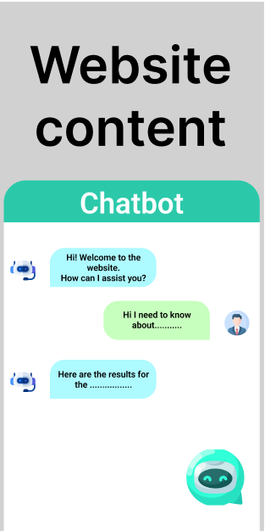

Fig. 7. User interface for mobile version

* 1. *Technologies used*

This chatbot is built on top of python language with Keras and Natural Language Processing as its base. Using Keras neural networking technology, efficiency and accuracy of the chatbot is drastically increased. For the storage, relational database such as SQL and MySQL are used. Even cloud storages can work well along with this chatbot. The created model of the data is stored in ‘.h5’ file (or) hierarchical data format file to arrange the data according to its priority. The user interface and the underlying technology is inter-connected together with basic web development components like HTML, CSS, and Java script.

VII. Conclusion and Future enhancement

This paper proposes a chatbot, built on top of deep learning using Keras neural networking and Natural Language Processing. This application is very initiative and easy to use. Its main goal is to assist users with their queries. Also, this chatbot can be adapted to any application with basic training models. For example, e-commerce website can train this chatbot by just giving a limited amount of sample model. Whereas, service provider websites can uses the chatbot just by clearing the stored models and giving the models related to their theme.

Even though, there are multiple chatbots available in the market many are not up to the mark. This chatbot can be enhanced just by increasing the training layers. More the layer, more the efficiency and accuracy. In the future, this chatbot can be modified into a purely API based application so that each and every one with internet can access the chatbot and alter according to their need.

References

[1] Kathy Haan and Cassie Bottorff, *Web-statistics on modern life-style,* Forbes advisor <https://www.forbes.com/advisor/business/software/website-statistics/>

[2] Aishwarya Gupta, Divya Hathwar and, Anupama Vijaykumar, *Introduction to AI Chatbots,* vol. 9., Dayananda Sagar College of Engineering. <https://www.researchgate.net/publication/342880348_Introduction_to_AI_Chatbots>

[3] M Senthilkumar and Chiranji Lal Chowdhary, *An AI-Based Chatbot using Deep Learning,* Edition. 2., School of Information Technology and Engineering, Vellore. <https://www.researchgate.net/publication/338471898_An_AI-Based_Chatbot_Using_Deep_Learning>

[4] Bayan Abu Shawar and Eric Atwell, *Chatbots: Are they Really Useful?* AI Ain University and University of Leeds. <https://www.researchgate.net/publication/220046725_Chatbots_Are_they_Really_Useful>

[5] Ellis Pratt, *Artificial Intelligence and Chatbots in Technical Communication – A Primer,* Vol. 1., Cherryleaf. <https://intelligent-information.blog/wp-content/uploads/2017/09/A-Primer-AI-and-Chatbots-in-Technical-Communication.pdf>

[6] O’Reilly, Steven Bird, Ewan Klein and, Edward Loper, *Natural Language Processing with Python.* O’Reilly and Safari publications. <https://tjzhifei.github.io/resources/NLTK.pdf>

[7] Marco Slaviero, *Sour Pickles and Shell coding in Python’s serialisation format,* Edition. 4., Sensepost. <https://media.blackhat.com/bh-us-11/Slaviero/BH_US_11_Slaviero_Sour_Pickles_WP.pdf>

[8] Roger Borras, *Introduction to Deep Learning with TensorFlow and Keras libraries,* May 2018, Universität Autonoma de Barcelona. <https://sct.uab.cat/estadistica/sites/sct.uab.cat.estadistica/files/sessio_sea.pdf>

[9] Martin Adam, Michael Wessel and Alexander Benlian, *AI-Based chatbots in customer service and their effects on user compliance,* 17 March 2020, Springer Link. <https://link.springer.com/article/10.1007/s12525-020-00414-7>